Practical - 10
Practical Title: 10: Secure Login/Logout with Sessions, Role-Based Access, Timeout, and Remember-Me Token

Problem Definition: Develop secure login and logout functionality using PHP sessions. Verify

password using password_verify(), regenerate session ID after login,

restrict dashboard access, implement role-based redirection, session

timeout, and optional secure remember-me token.

Theory

1. Are sessions started and destroyed securely?
ANSWER: Yes, sessions are started and destroyed securely. A session is created after successful login using PHP session_start(). During logout, session data is cleared and the session is destroyed using session_destroy().

2. Is password_verify() used correctly?
ANSWER: Yes, password_verify() checks the entered password against the stored password hash. Passwords are hashed using password_hash() before being stored in the database.

3. Is unauthorized dashboard access blocked?
ANSWER: Yes, the auth.php file checks whether the user is authenticated.

4. Is session timeout implemented?
ANSWER: Yes, the session expires after 15 minutes of inactivity. The system compares the current time with the user's last activity timestamp

5. Are admin and student users redirected to appropriate dashboards?
ANSWER: Yes, the system checks the user's role after successful authentication. Admin users are redirected to admin-dashboard.php. Student users are redirected to student-dashboard.php.

Implementation/ Output/Result:

Evidence of Work (Screenshots):

Secure Login page:
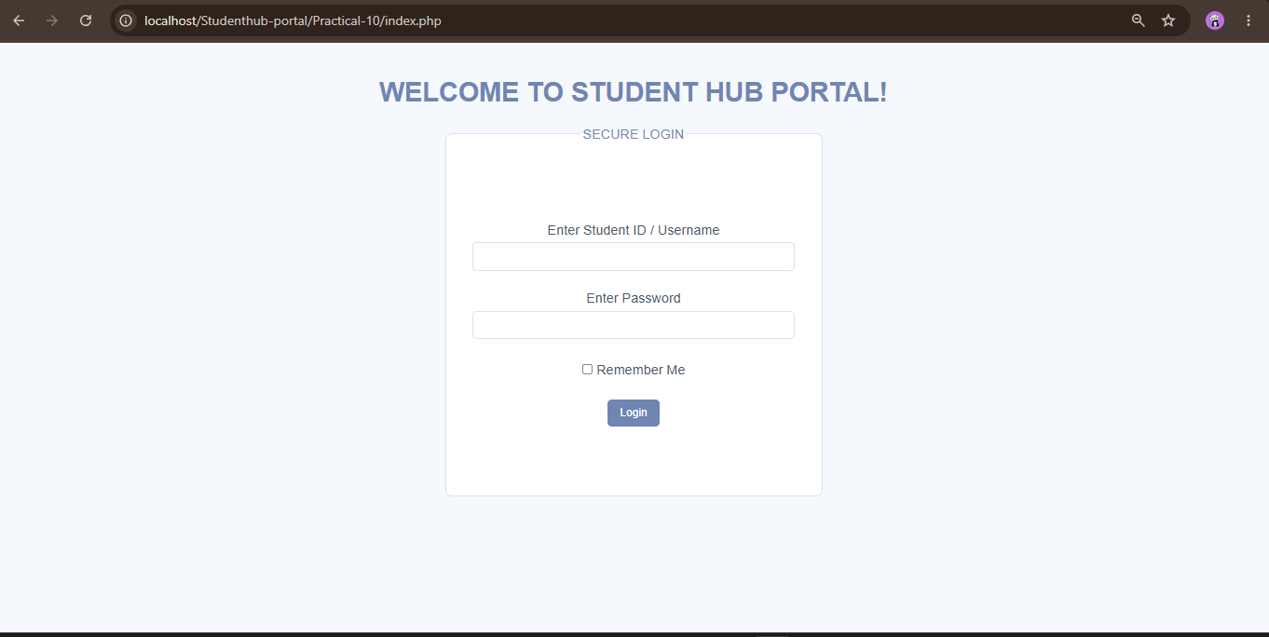

Entering admin credentials:
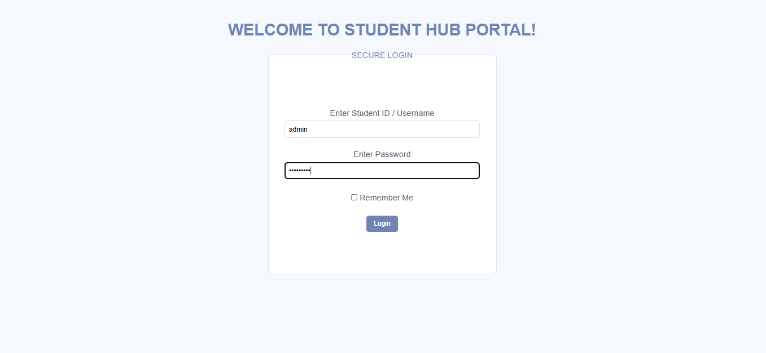

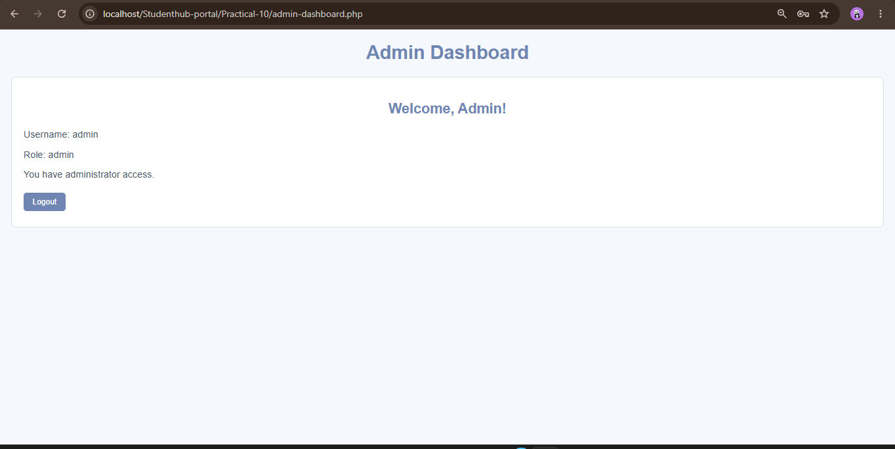

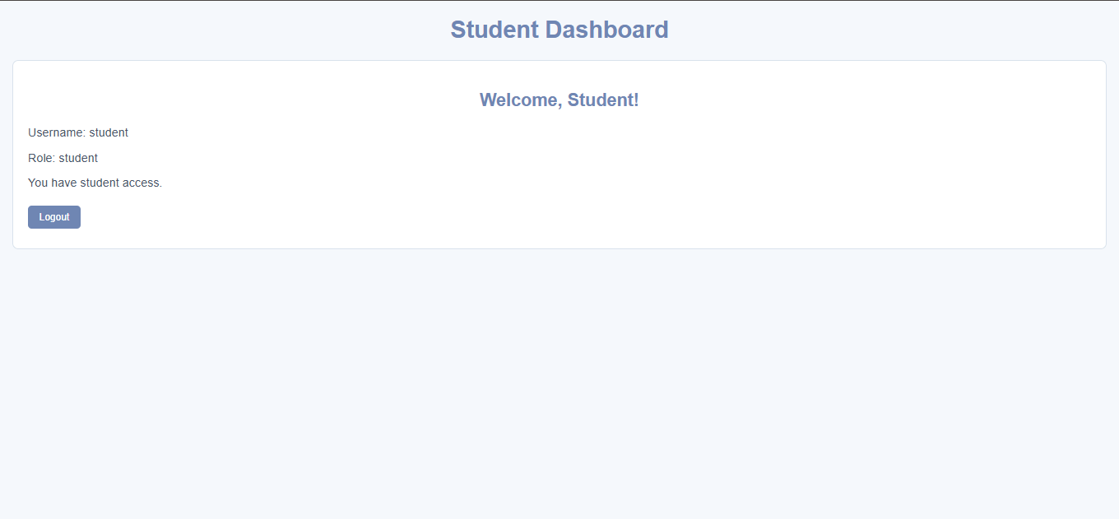

Invalid inputs:
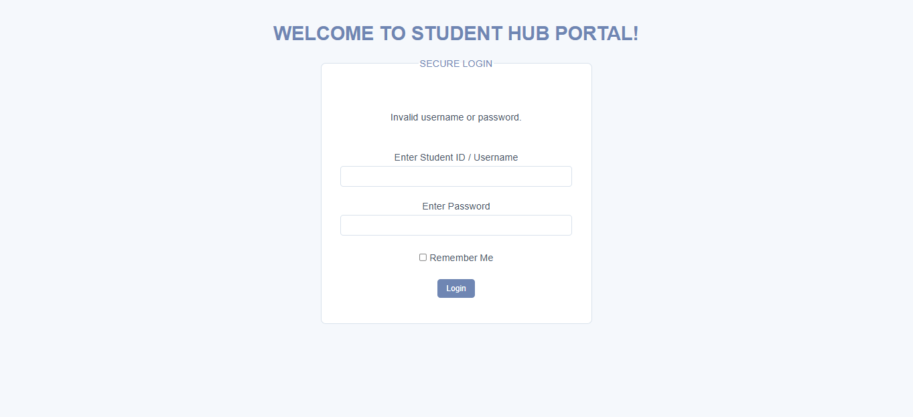

Session expired:
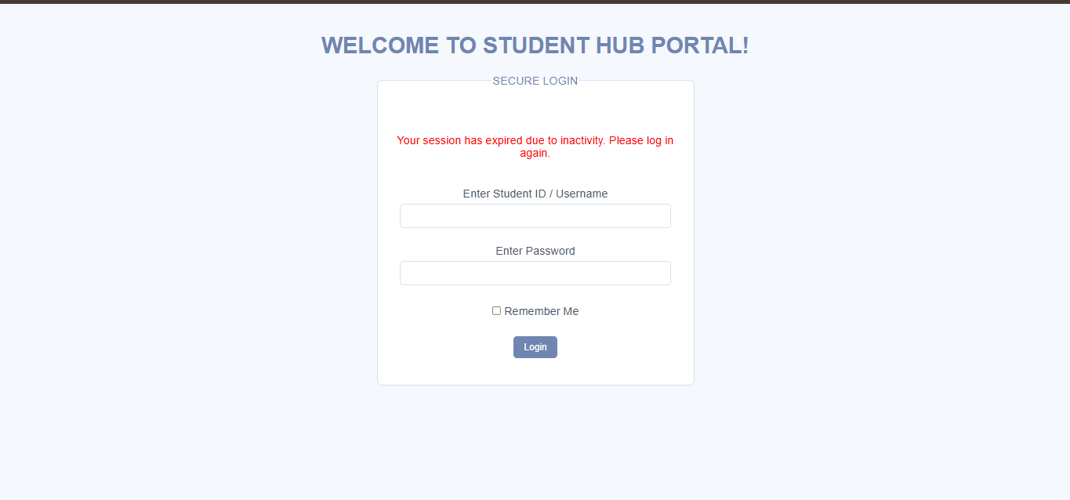

Database:
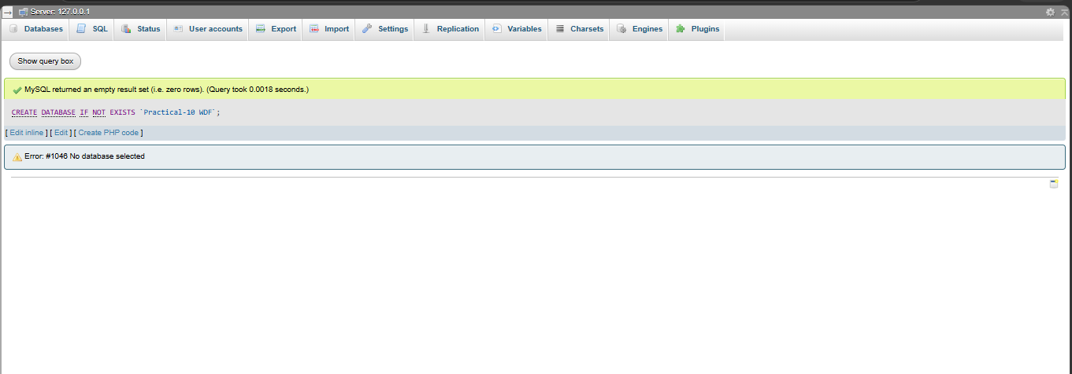
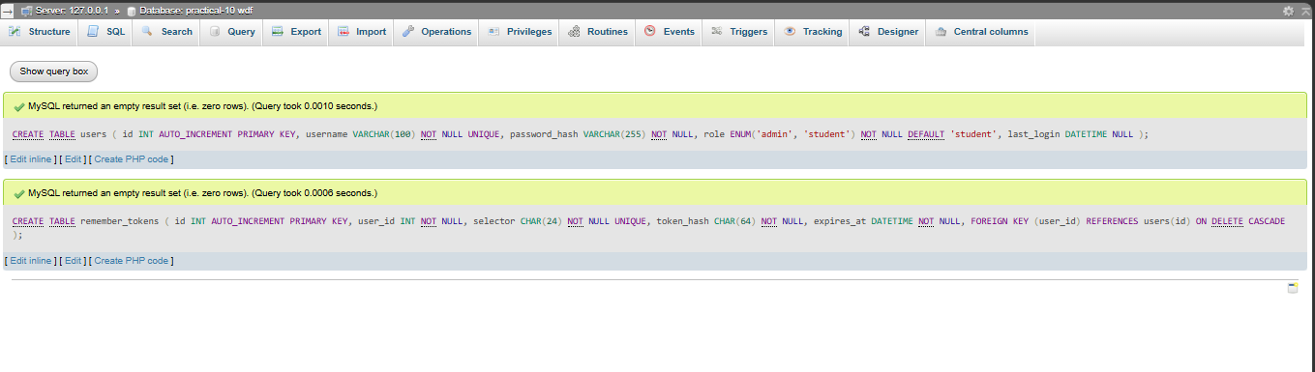

GitHub Repository Link:

https://github.com/shiloni28/WDF.git

E.Challenges Faced:

- Encountered the No database selected error
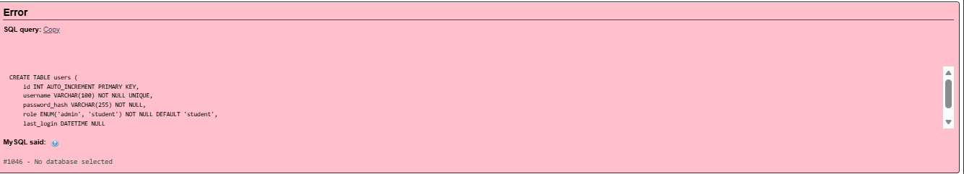

- Encountered a Foreign key constraint incorrectly formed error due to an issue with the foreign key reference between the remember_tokens and users tables.
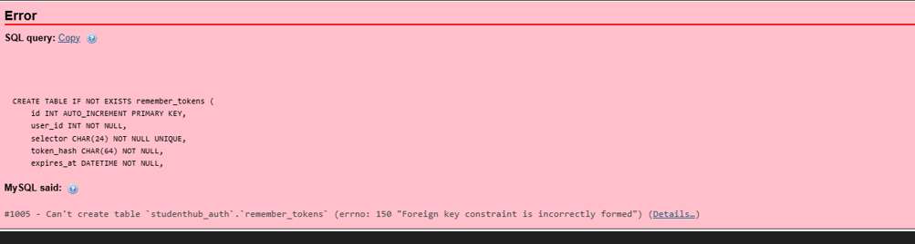

• Creating the required database and tables with the correct names.
• Generating and storing password hashes for demo user accounts.
• Resolving the invalid username or password error during login.
• Implementing separate dashboard access for admin and student roles.
• Testing session expiration without waiting unnecessarily long during development.

F.Learning Outcomes:
- Learned how to implement secure login and logout functionality using PHP.
- Understood session creation, session ID regeneration, and session destruction.
- Learned to store passwords securely using password_hash().
- Understood how to verify passwords using password_verify().
- Learned to implement role-based access control for admin and student users.
- Understood how to prevent unauthorized access to protected dashboard pages.
- Learned to implement session timeout based on user inactivity.
- Understood the use of cookies and secure remember-me tokens.

Faculty Remarks:

